**IBM ASSIGNMENT-2**

PYTHON CODE:

import random import time while(1!=0):

temperature = random.random() humidity = random.random()

#round(temperature,2) #round(humidity,2) ("print Temperature: ","%.5f" % temperature) print("Humidity: ","%.5f" % humidity) time.sleep(2) if (temperature > 0.7): print("high temperature")

if ( humidity >0.7):

print("high humidity")

import time

from w1thermsensor import W1ThermSensor

sensor = W1ThermSensor()

while True:

temperature = sensor.get_temperature()

print(“The temperature is %s celsius” % temperature)

time.sleep(1)

print("")

**EXECUTION RESULT**

Program

import time

from w1thermsensor import W1ThermSensor

sensor = W1ThermSensor()

while True:

temperature = sensor.get_temperature()

print("The temperature is %s celsius" % temperature)

time.sleep(1)

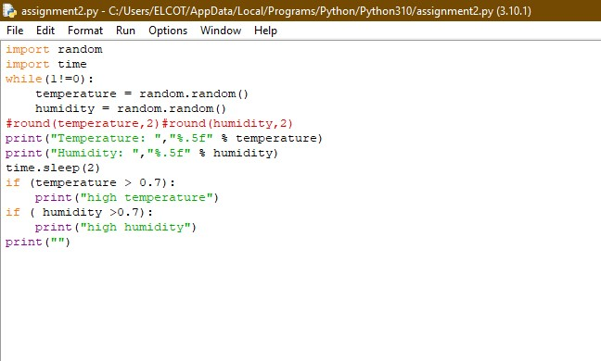

Output

